Class Book Review
SeeSaw Directions for Self-Selected Reading Station
1. Find the SeeSaw app on the iPad | 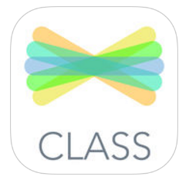
2. Click I’m a Student
3. Scan the QR Code posted at your station
4. Select your name
5. Select the Camera tool to take a picture of your book.
6. If you need to rotate the picture, select the arrow.
7. Use the microphone to record the reading of your book review. When finished, click the green check.

To re-record, select the X and then delete.

8. Use the Text tool and select Add Caption to add the title and the number of stars.
Finished? Click the green check.
9. Your work will be Waiting For Approval by Ms.Cherry. She will review and then approve your work. If your work is not approved, you will receive feedback and suggestions in the Comment section under your post.

